**05-499D Game Design Studio Project 2 | Process Documentation**  
Angela Liu, Ara Lee, Benjamin Boesel, Jeel Jasani, Lisa Imas, Sunny Li

Our game is based on a rare narrative element, a player motivation, and a player type. Our narrative element is multi-protagonist, our player motivation is family and our player type is escapism. Starting from brainstorms of each of these aspects individually to coming up with our final game, we iterated through numerous ideas and below, we have documented this entire process through notes, descriptions, and photographs.

**First Meeting**

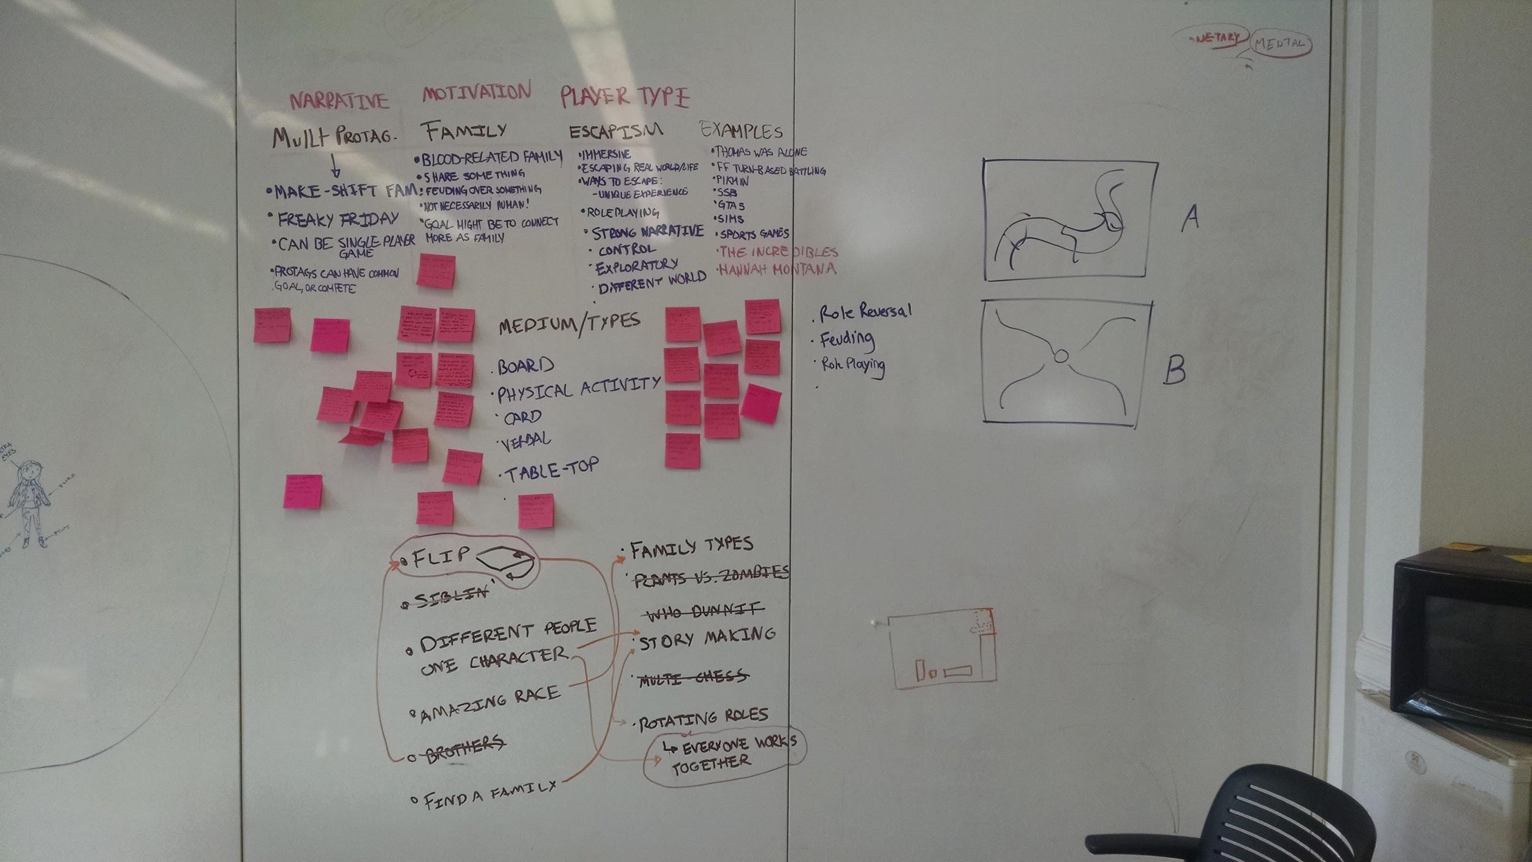

During our first meeting, we began with brainstorming ideas/concepts/themes associated with each of the mandatory game elements multi-protagonist, family, and escapism. For multi-protagonist, our ideas revolved around different ways that a game could contain multi-protagonism. For family, we discovered many ways that a family can be portrayed in a game, their relationships with each other, and possible points of bonding or contention. For player type, we struggled with a concrete definition of escapism at first, but slowly thought of more solid ways to interpret and implement escapism within a game. Along the way, many of us used currently existing games as examples and we made sure to write these down also. The ideas written on the board were the broader categories of all the ideas that we generated fit under.

After exhausting our brainstorm phase, we moved on to quickly thinking of different game mediums/types. Now that we had the majority of the topics and aspects of our future game written on the board with our brainstormed ideas, we each took some post-its, broke up for about 10 minutes, and brainstored individually several games that incorporated ideas from each category. At the end of this individual session, we all took turns explaining the games on our post-its that we came up with and whenever people had feedback, questions or comments, we stopped to discuss. This took quite some time but at the end we were able to discuss as a team and come up with the most popular topics/game goals from all of our ideas. Those ideas are in the two column list at the bottom of the board.

Once the general game ideas/goals were up, we began the process of elimination. To begin, we tried to see if we could combine elements from different games into one. By brainstorming this way, we were able to come up with several fascinating and exciting games. We found ourselves in a situation where we hadn’t eliminated any games yet, but ended up with an even bigger repository of ideas to choose from. While this is a better problem to have than the situation where there are no ideas, we were getting overwhelmed by all of the ideas and needed desperately to cut some ideas out. To do so, we found the games that did not tie into our constraints well. Then we went through and crossed out ideas that would not be feasible for our time and resource constraints. We continued to discuss the remaining game ideas but were unable to come to any conclusions or eliminate any more ideas. Our main problem was that all of our ideas were too unstructured. For all of the ideas, we didn’t have any concrete game play rules, pieces to play with, format, or even medium. We only had the concept of the games. Realizing that we were no longer being productive or efficient, we decided to each go home and come up with a full fleshed game to bring back to the group the next day.

**Second Meeting**

It was during this meeting that we finally decided on a set a tentative rules and gameplay to playtest. Instead of first coming up with a concept or narrative and creating a game from that, we tried a reverse approach. We tried to come up with a fun and playable game first, and then modify it to fit more appropriately with the constraints. We were inspired by the magnets and how they could be moved when connected with string. We spent so long trying to brainstorm board games which would exist on a grid or fixed spaces, that this organic and unconstrained way of moving seemed like a fresh idea we could work with.

We came up with a basic set of rules and began playtesting to validate our idea:

1. The only constraint of movement was by length of the string and how many magnets you could move (3)
2. In order to kill someone’s magnet, you had to “envelop” them in your piece (see picture below for diagram)

Some of the good things we noticed:

* Moving the magnet nodes was very satisfying and the string was enough constraint; didn’t need a grid or any guidelines
* It’s a very easy game to understand and learn; fit with players’ mental models
* It was a fun game!
* Players were trying to strategize throughout the game

Things we needed to fix before class playtesting:

* The pieces started too far away from each other; gameplay was slow in the beginning
* Did our game relate enough to family? To escapism?

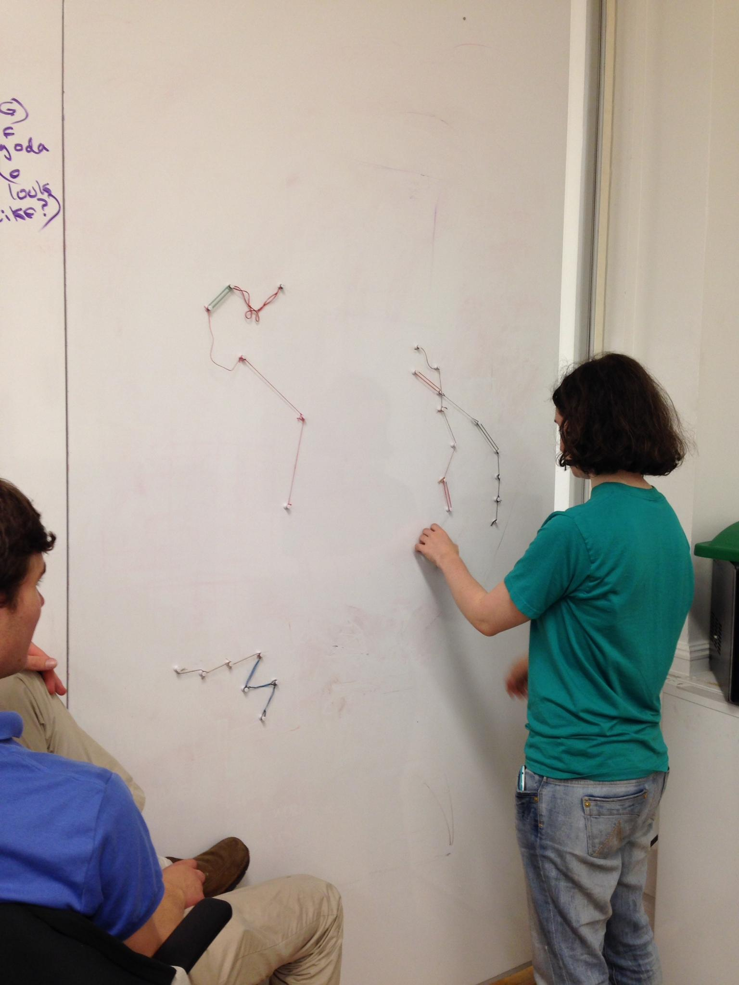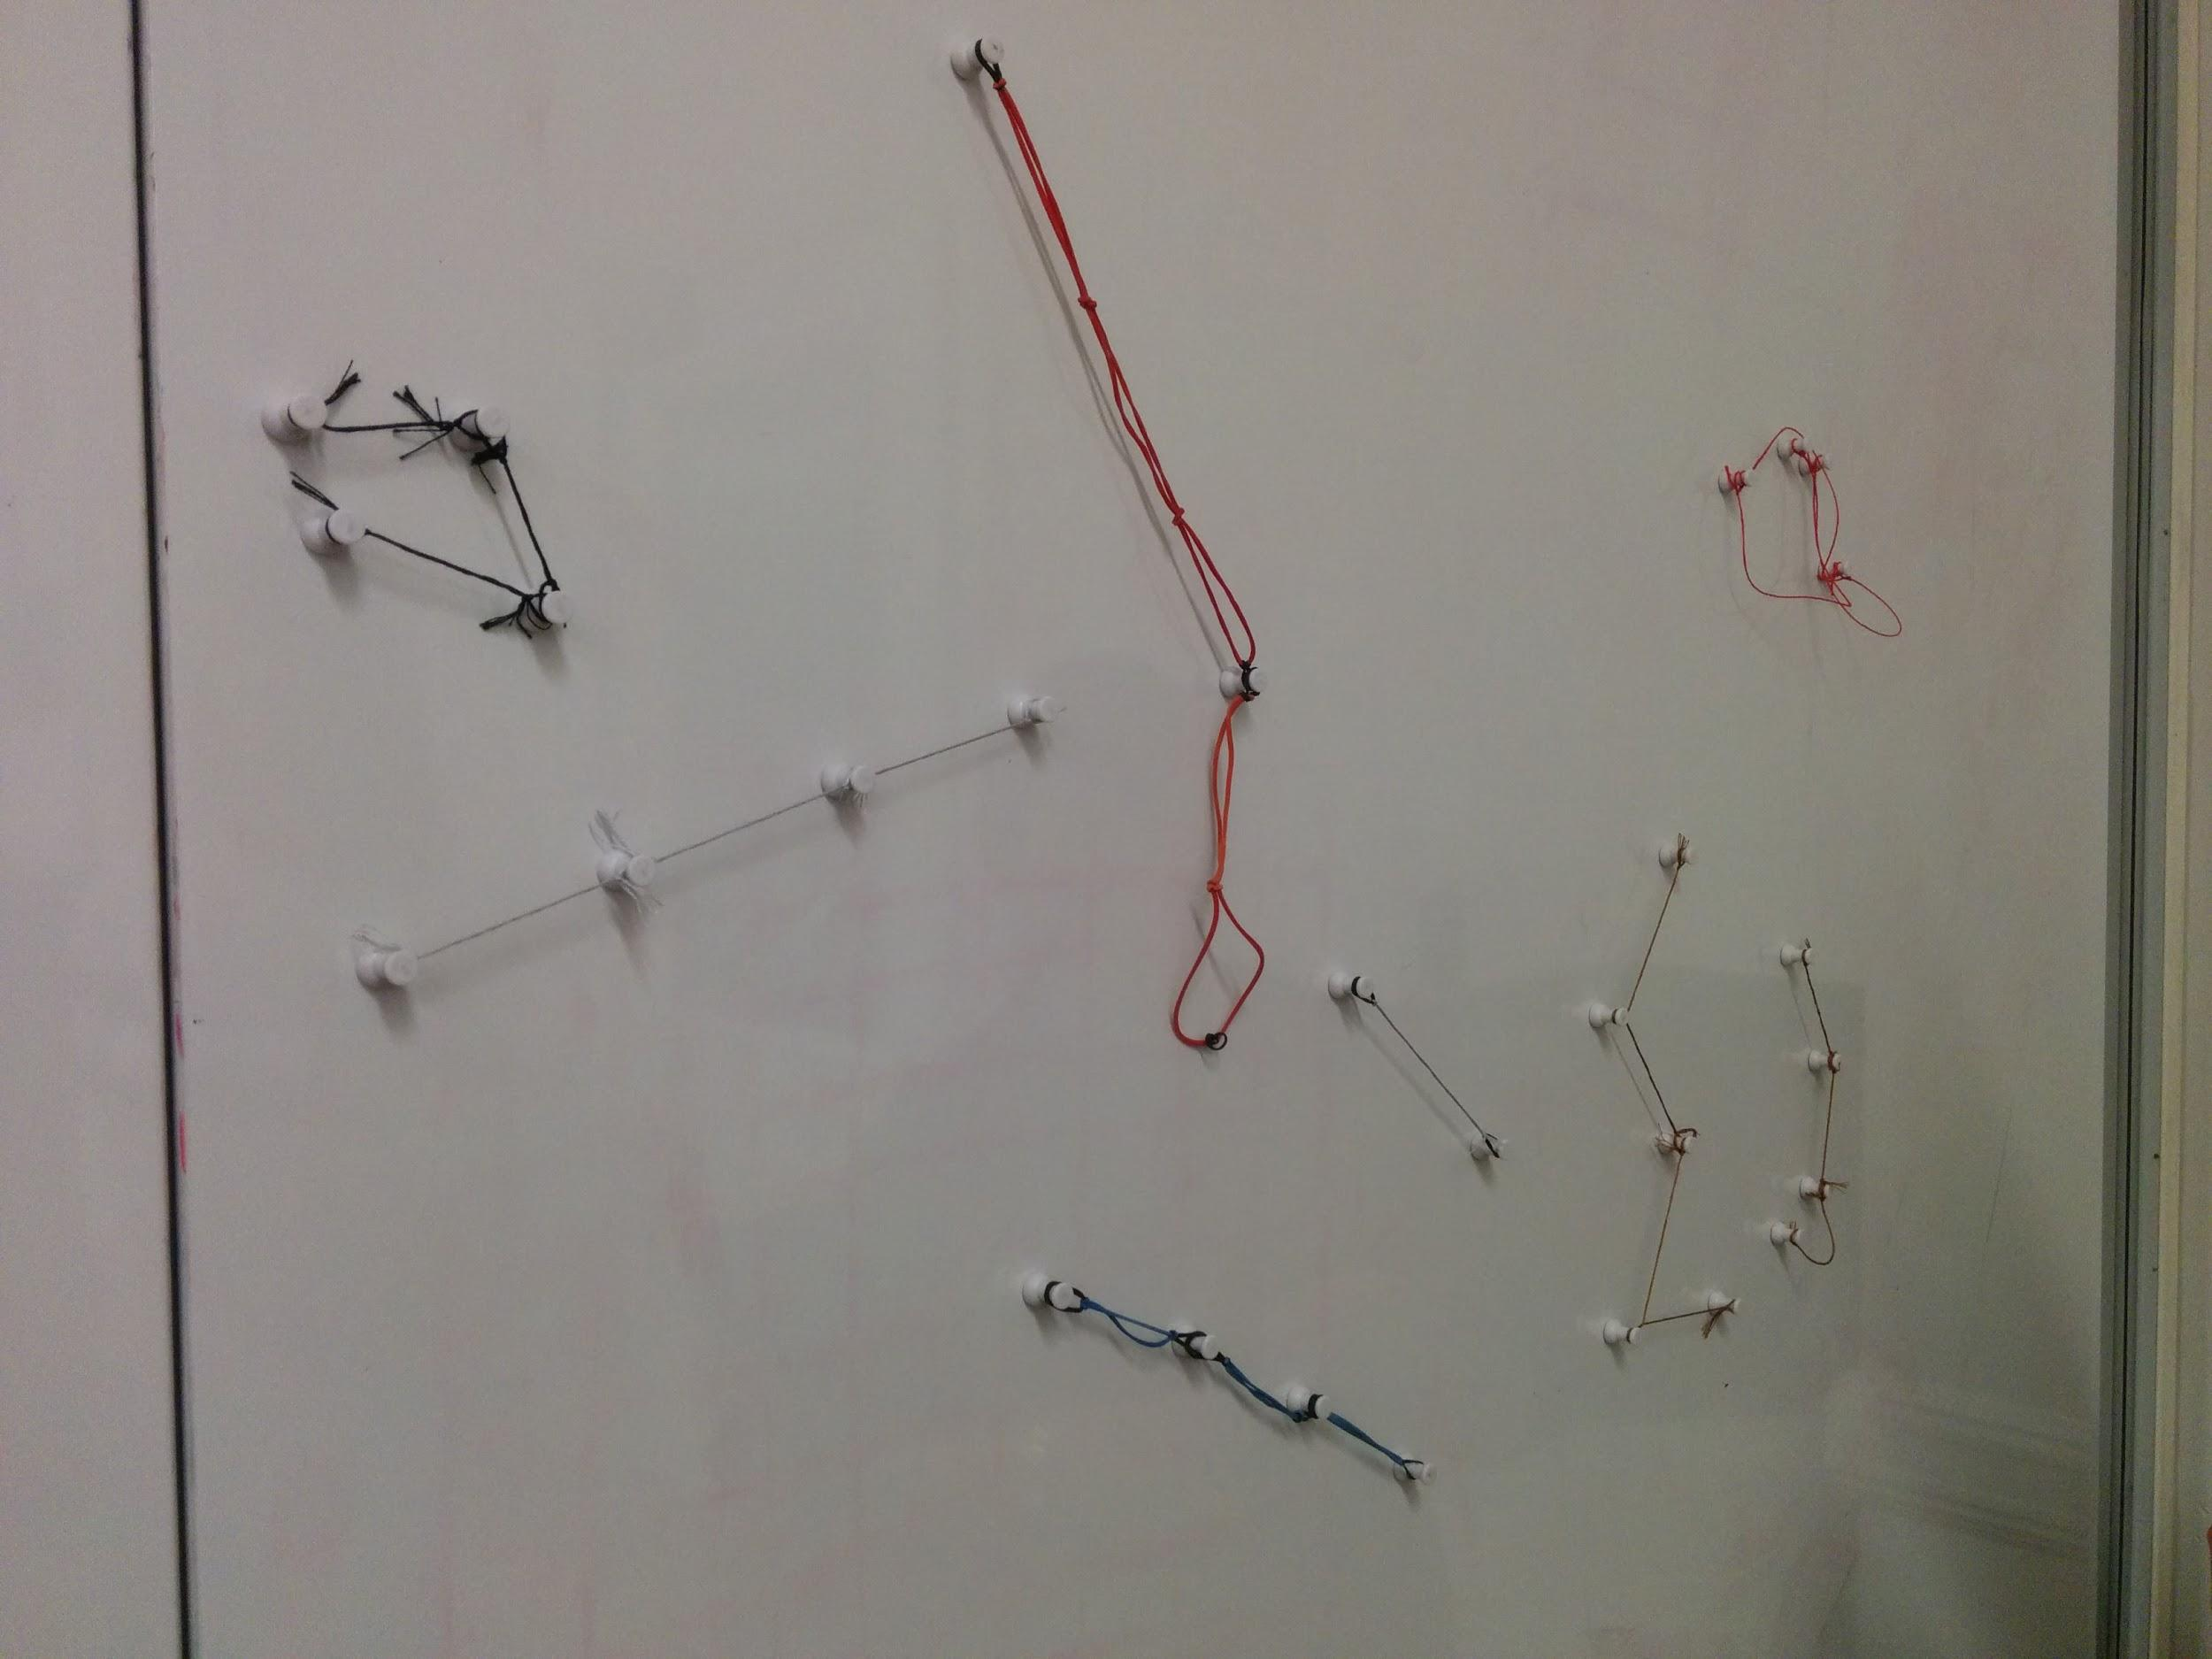

Playing around with the best way to link the magnets.

Things tried: string, rubber band, string + rubber band

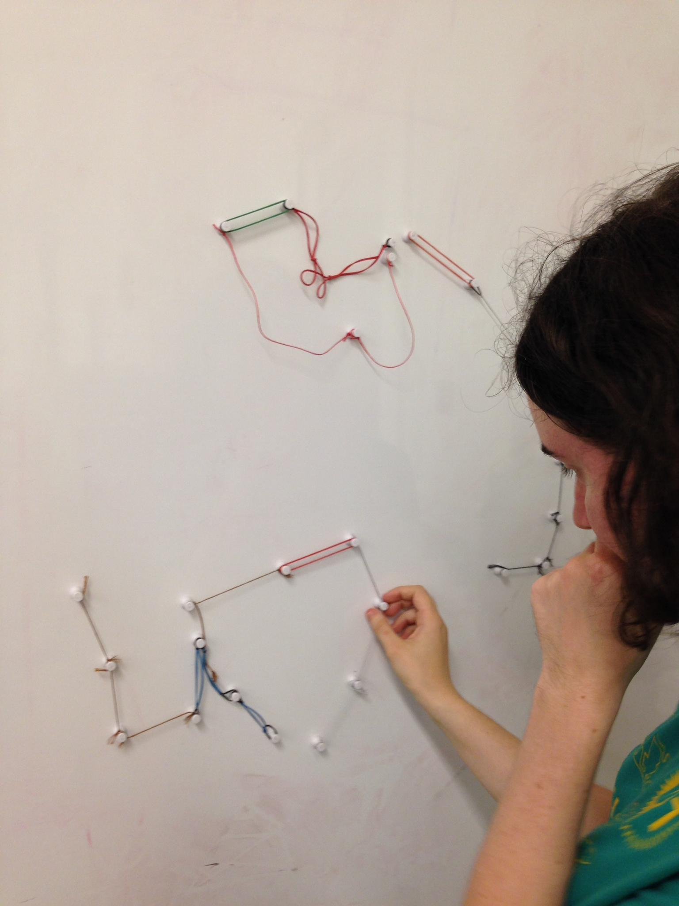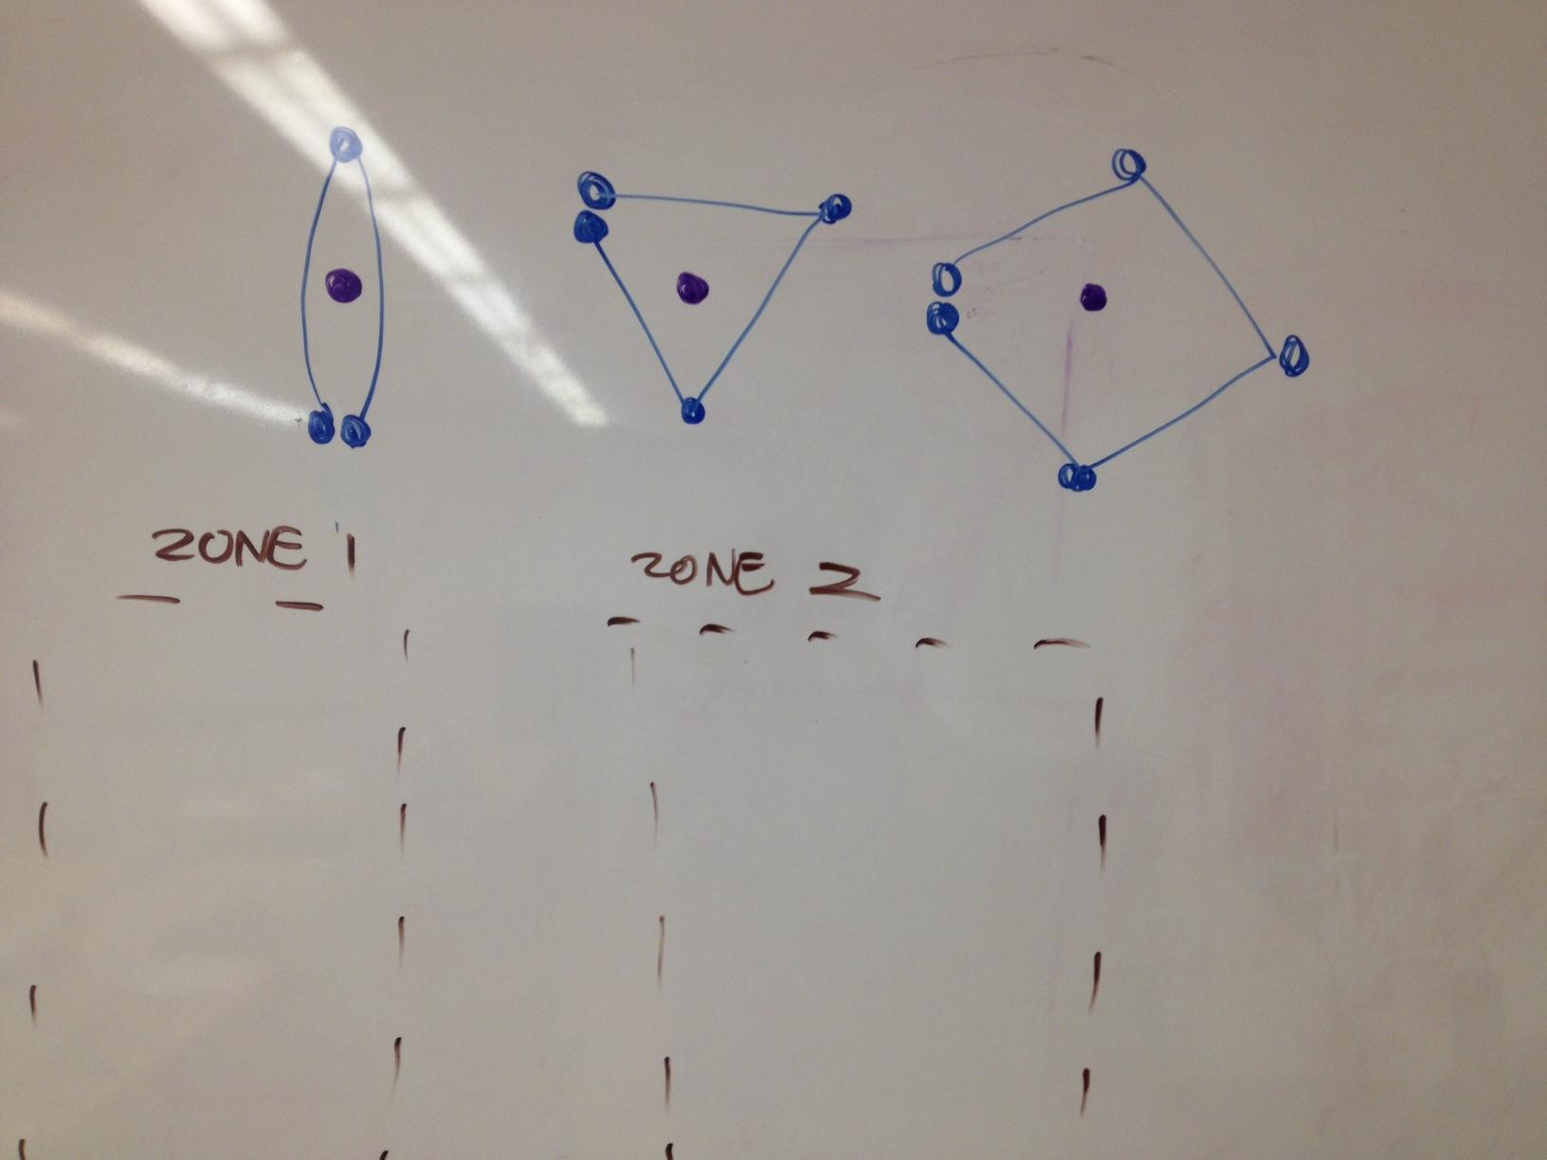

Defining the ways to kill and debating to create

zones for the two players to begin in.

**Third Meeting**

In this meeting we refined our idea of the game from the previous meeting and came up with the final playable prototype. After testing with strings and rubber bands of different sizes we narrowed down on the materials and sizes we want to use. The following was our final list of materials -

Materials:

* 12 pin magnets per player
* 10 rubber banded strings per player
* a white board

Once we had our materials finalized, we went on to discuss player movements and characters in the game. We fixated on the child to be made of 2 pins and the mother to be composed of 10 pins. We came up with the placement of the pins on the board and then actually playtested the game amongst ourselves. The final rules at the end of that meeting were as follows -

Rules

1. Place all pieces behind the line
2. Place the baby behind the mother
3. Decide who plays first
4. Each player can move upto 3 pins per turn
   1. When you move a pin, you cannot drag any of the other pins with it
   2. You can cross over your own string or the other player’s string
   3. You must completely surround the opponent’s pin in order to “kill” it. Once you surround the piece, it is dead and removed from the playing field and the opponent’s string breaks at that point from where the killed piece was removed.
5. The first player to capture the opponent’s baby wins.

Our narrative behind the game was as follows -

Narrative

A new era dawns over the land! The two queens of neighboring kingdoms have each given birth to a child: the royal baby who represents a new age of prosperity for each of their lands! “Which is why the child must die,” each kingdom hushedly whispers amongst themselves, eyeing the other kingdom’s newborn. The kingdoms rally and set out to kill the children. However, their families, will allow no such thing, and will go to any lengths to protect their child and retaliate.

The great land of the warring kingdoms will see no peace until one of the newborn children is dead. The only question is: which will die, and which will survive?

**In-class Playtesting**

We received some really good suggestions from our in-class playtesting session. Here are some of the observations made by us as well as the other designers.

Observations

* The mother piece is too long.
* The two players should start closer to each other on the board, it takes very long for them to meet.
* Magnets are hard to get off the board.
* When the pieces cross over each other, the rubber bands get tangled.
* The child piece can keep running easily as there are no boundaries.
* The game overall is very aesthetic and pretty.
* The narration was really nice and provided a good setting for the game.
* There is no incentive to move the baby until the opponent’s mother attacks.
* As pieces began to split up the dynamic of the game sped up a lot.
* The click sound was very satisfying. You could hear three click sounds and know the player’s turn was over.
* A lot of the moves were arbitrary. People noticed strategy, but the players were not using it.
* There are different approaches that novices and experts might use to play the game.
* Slow start was really good to establish the strategies.
* Once the strand separated the multi protagonist component really stood out
* There was a disconnect between the story and the game.
* The game resembles constellations.
* It is unclear how you define kill/encompass.
* Beautiful auditory feedback. Really elegant.

Suggestions:

* Take the game to 3 dimensions.
* Add game elements that foster the play of the babies
* Move all magnets at the same time.
* Start closer together.
* Have a mechanic to form shapes. Add value to the short ones.
* Make the baby start off in a vulnerable state. Maybe they start in the middle.
* Choose strategically to release from the strand when the baby is safe.
* Use a cork board to constraint the baby in a space.
* Cork board would also allow you to trap things against the edge of the board.
* Narrate it as a baby would suggest saying how it can’t move.
* Variable length pieces instead of standard length.
* How about you play with people instead of magnets.
* Split the pieces to move them faster.
* Add environmental components that add to the strategy of the environment.
* Use longer strings to cover distance faster.
* Don’t necessarily need to move pin where the string stretches all the way.
* Add a 2 magnet “king” piece to defend at the homebase.

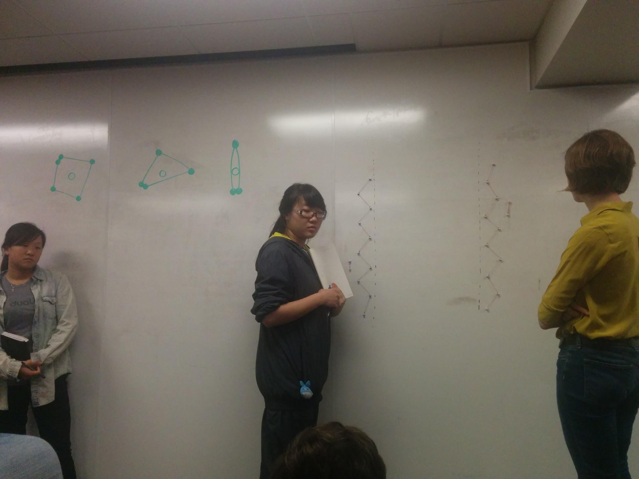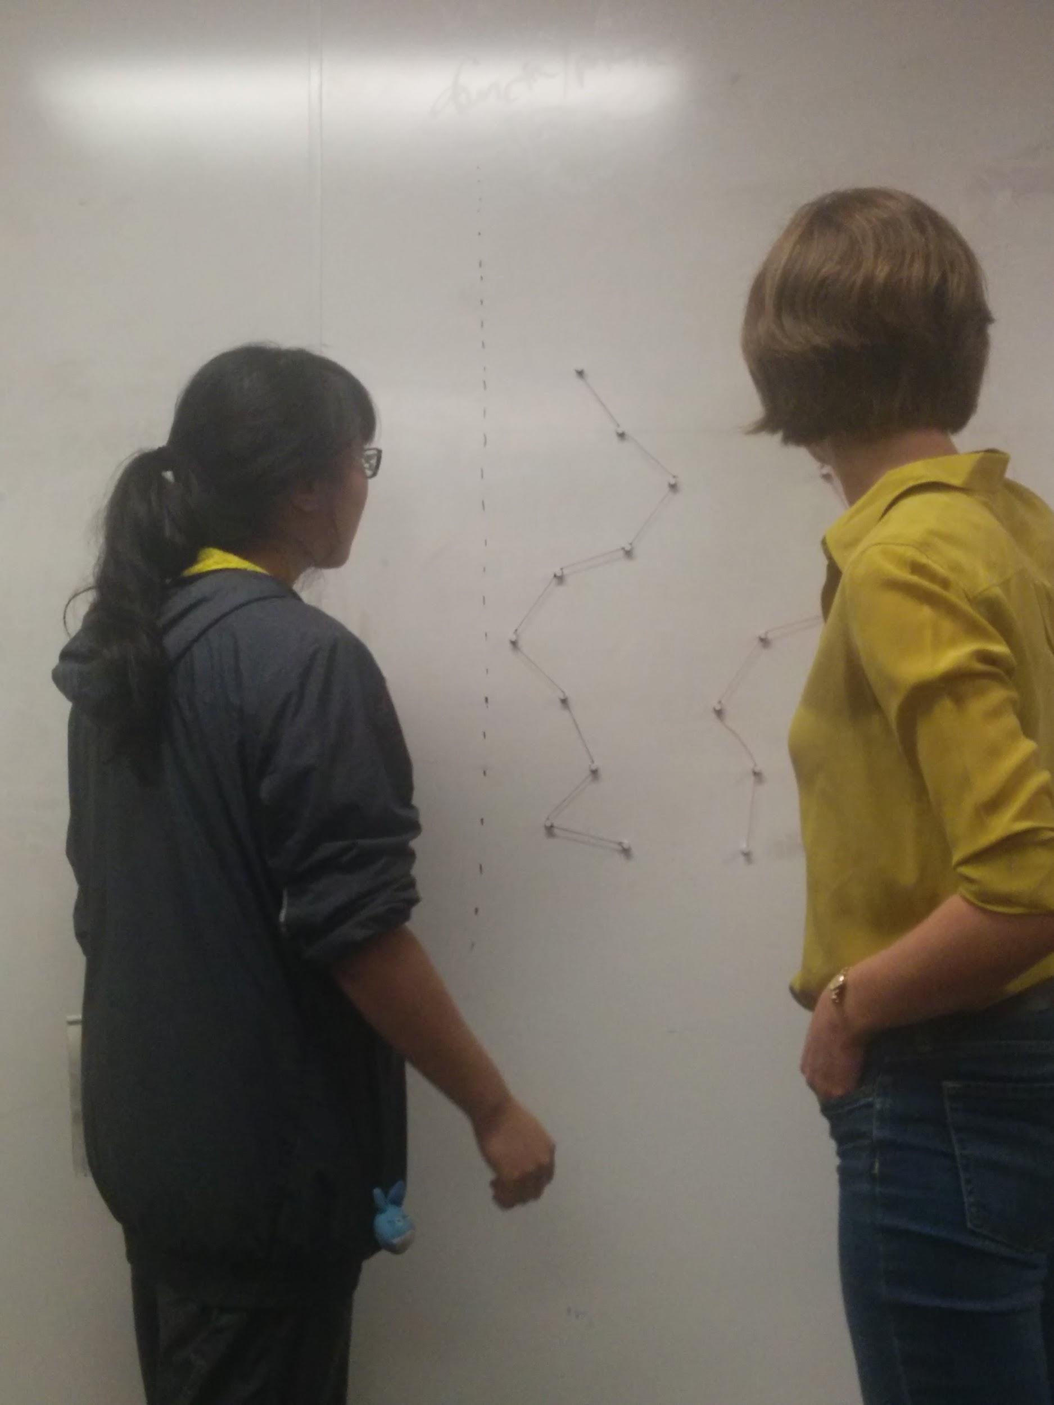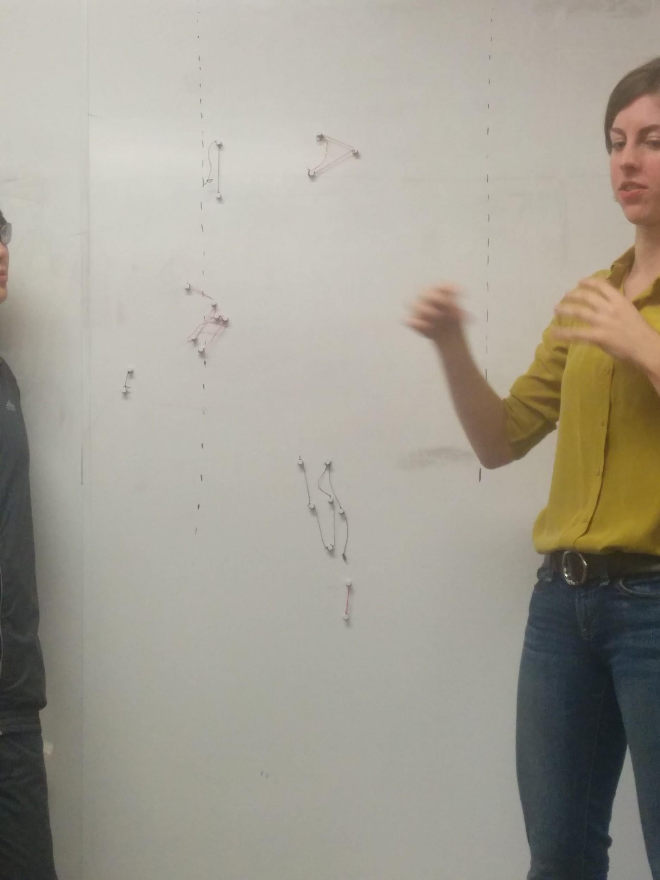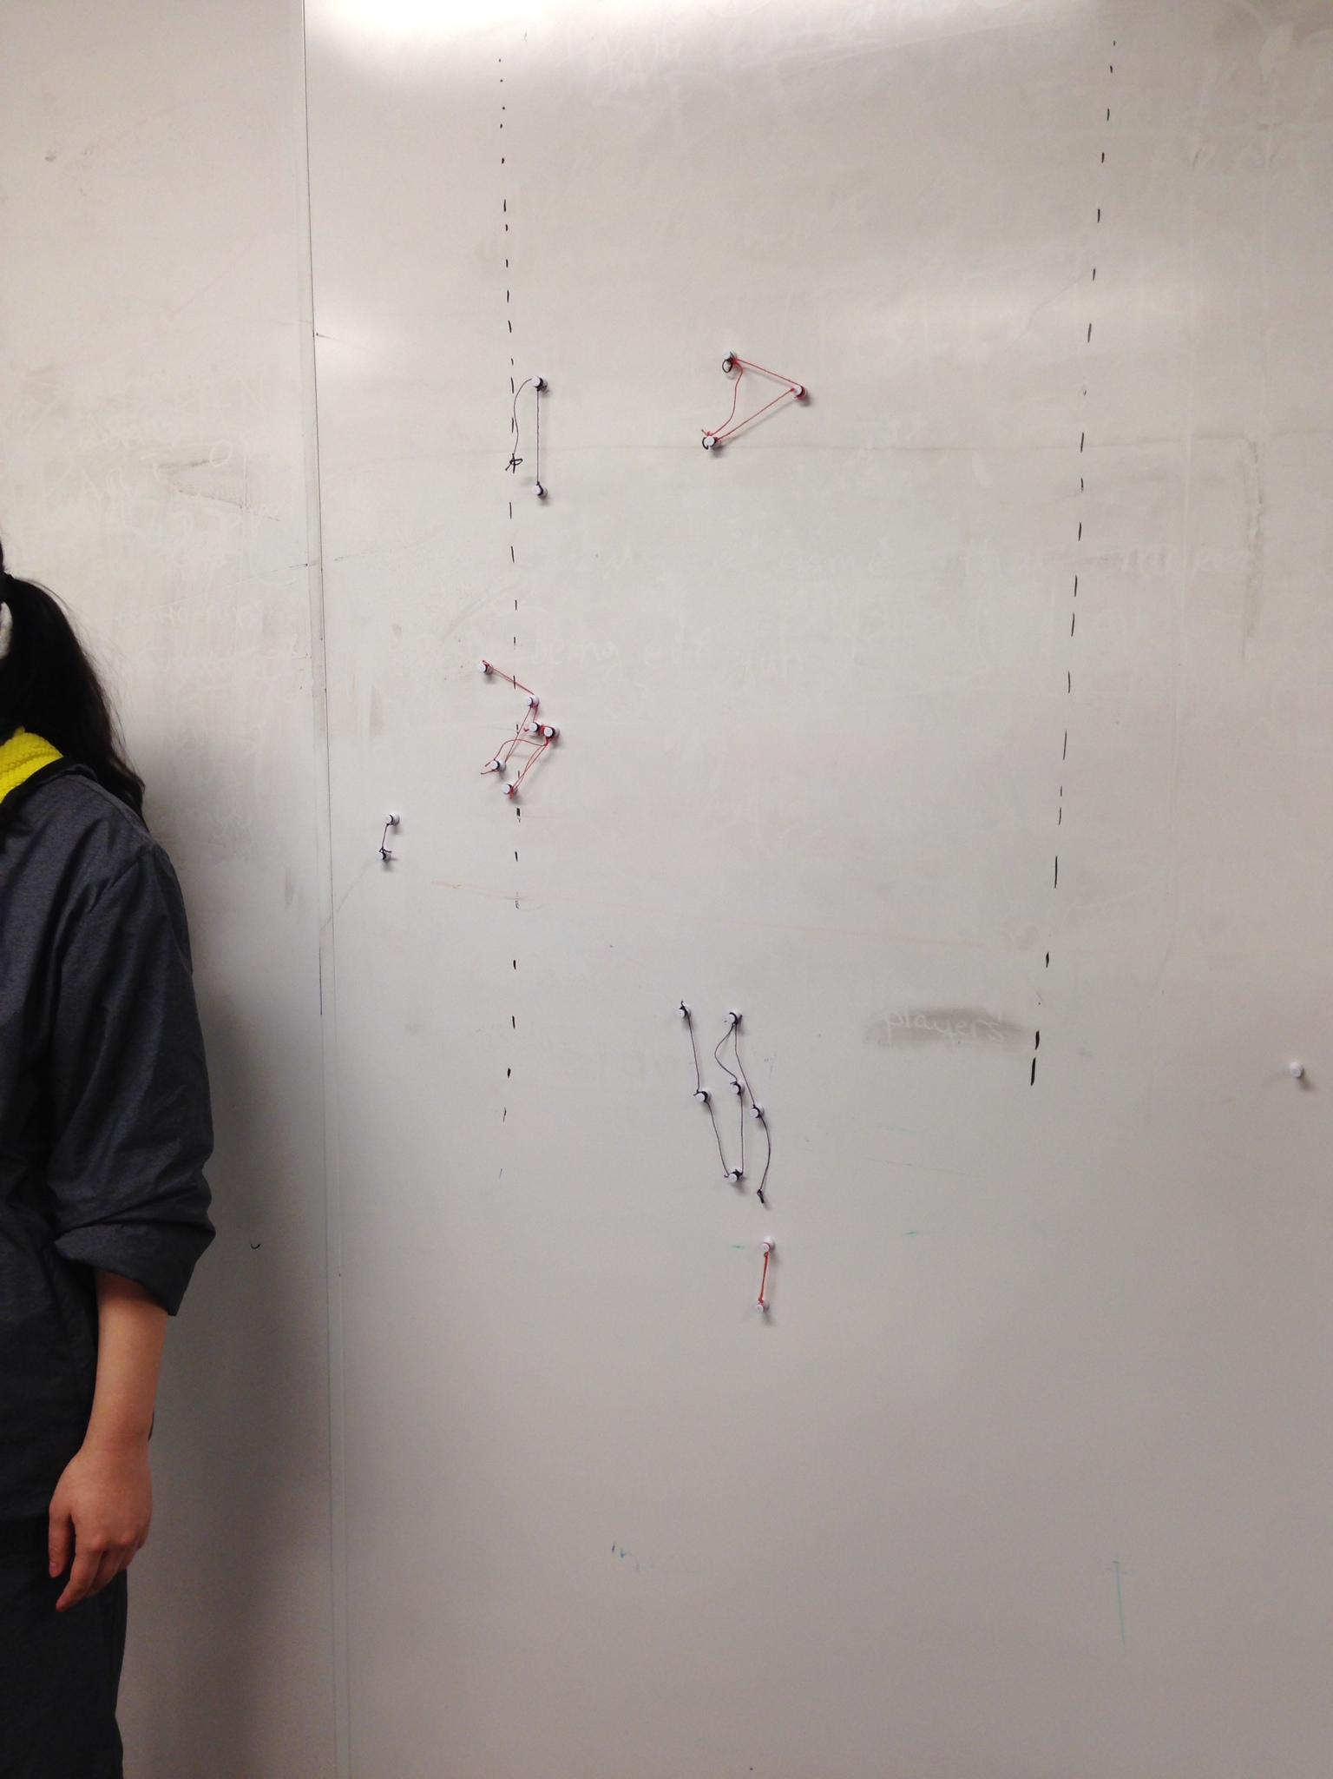

**Fourth Meeting**

**Playtesting different game alterations**

After the in-class playtest, we looked at some of the feedback we’d gotten and made alterations to the game to try and solve the problems that were brought up in class. Here is a list of the changes we made:

* allow splitting at the beginning of the game to whatever formation the player wants
* placed “game area” boundaries that could also be used to box pins in for a kill.
* start player pieces closer together.

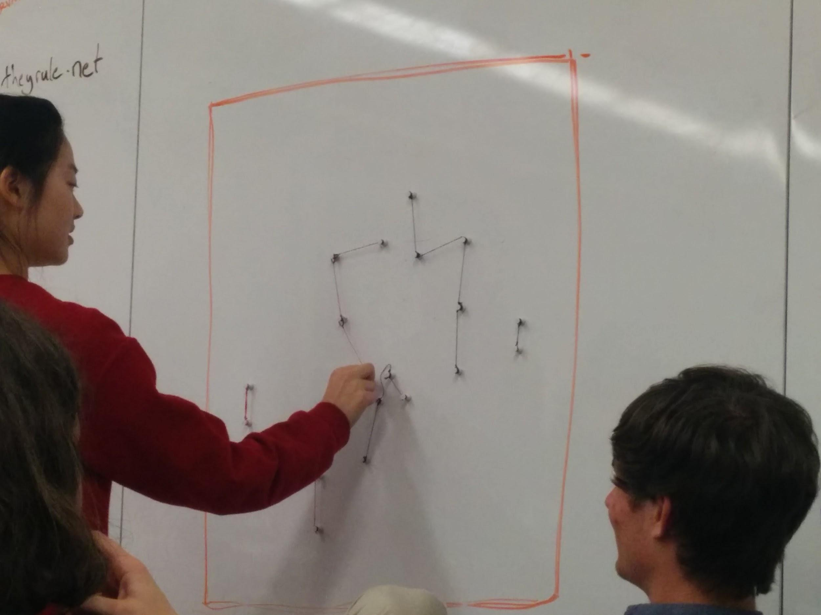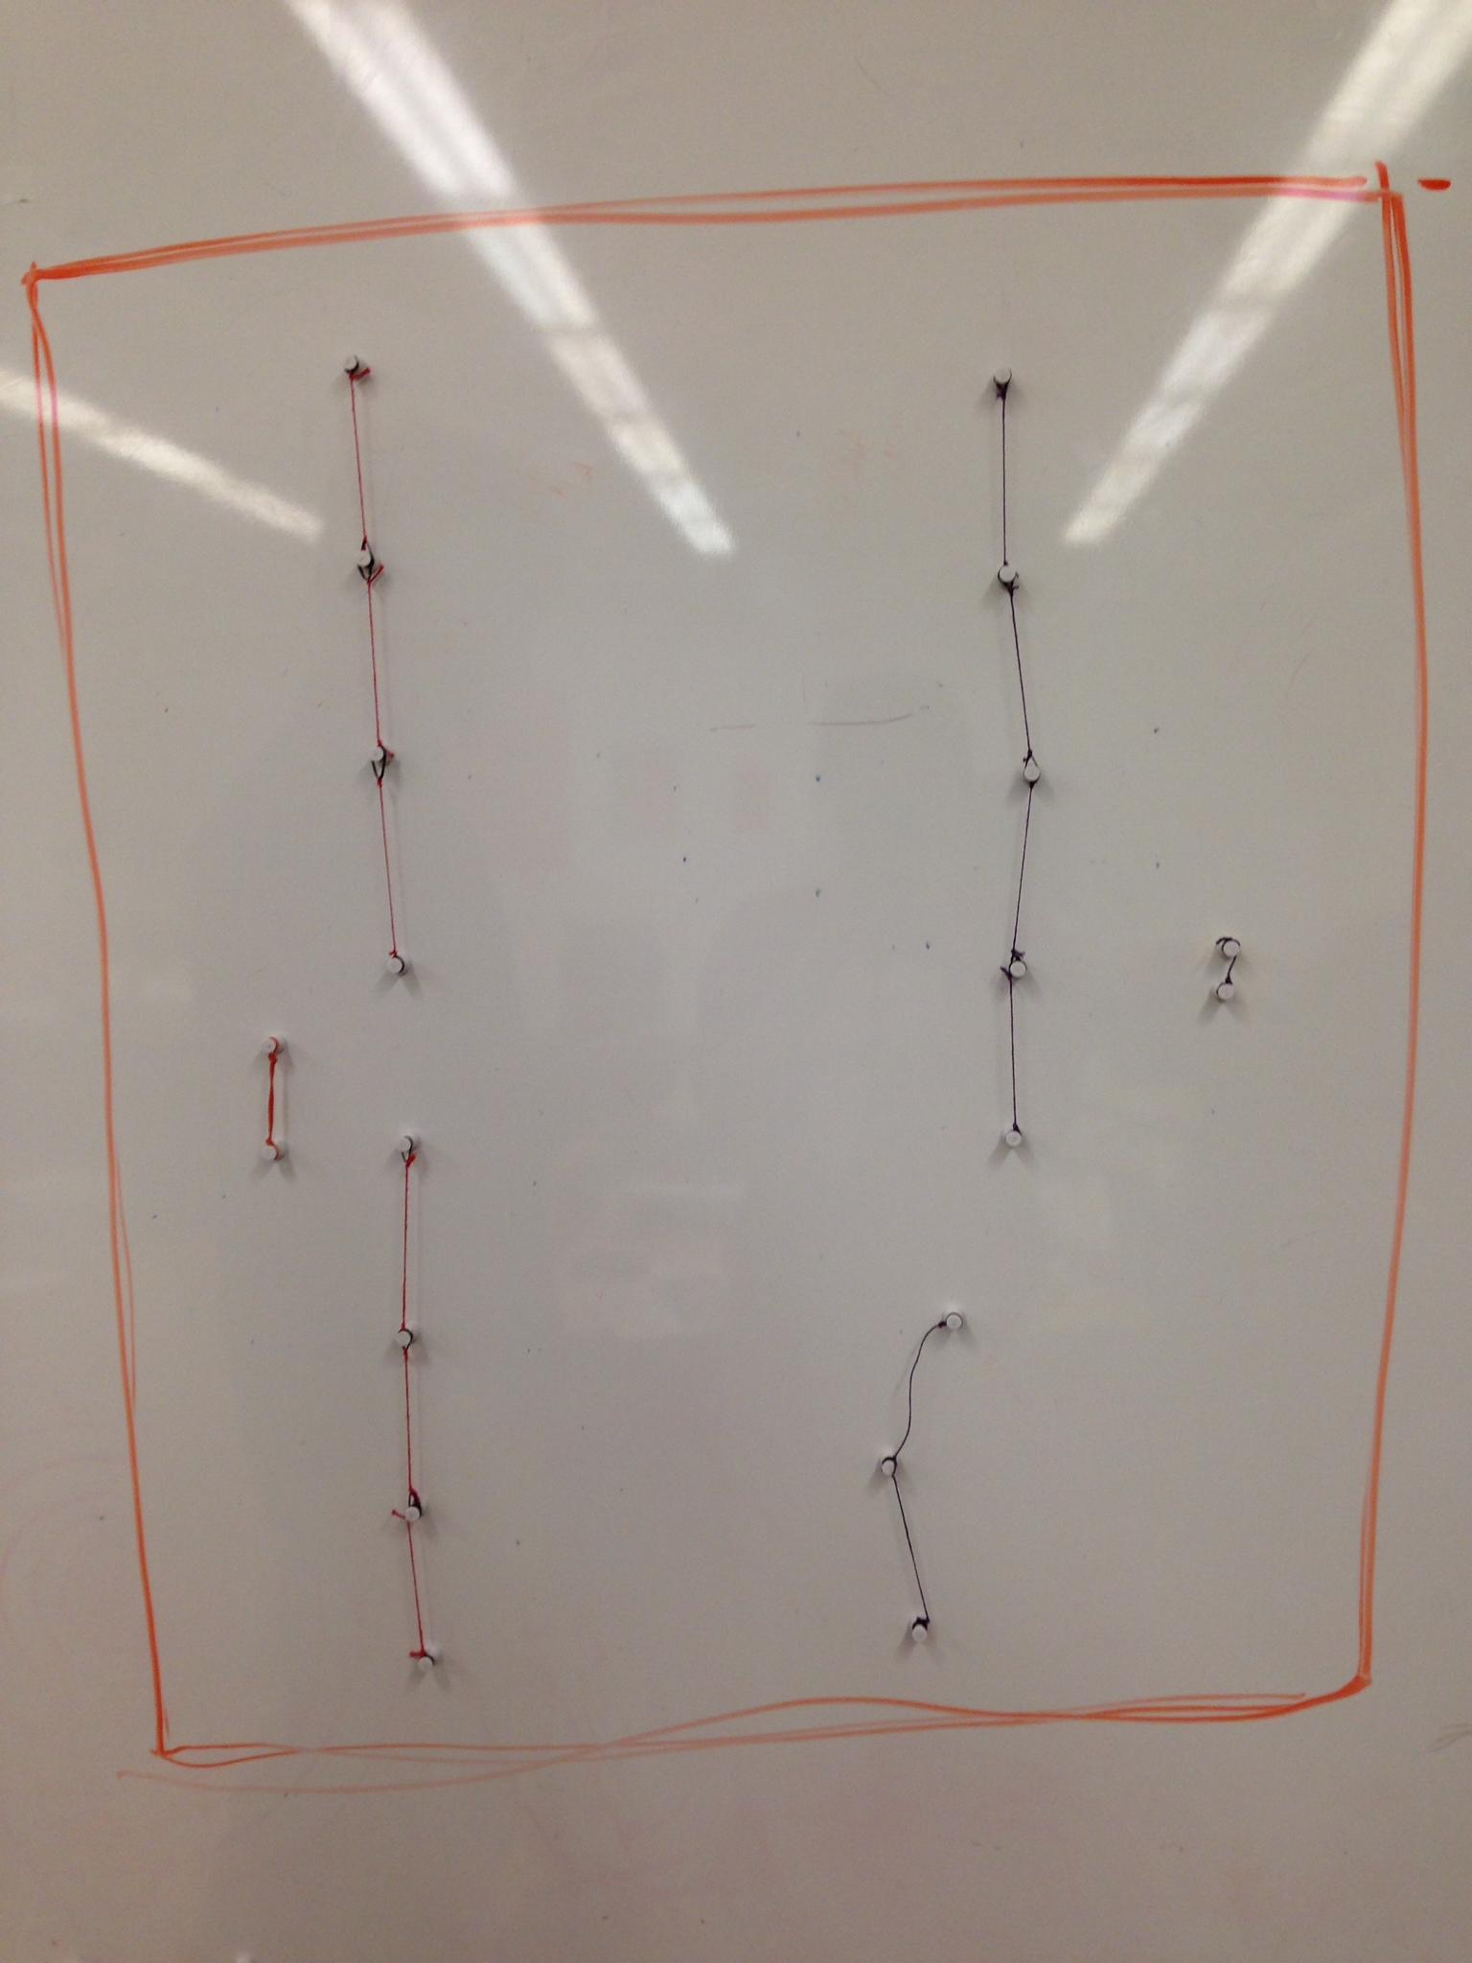

We found that allowing players to split made gameplay quicker and much more fun. Attacking was much easier and interaction between player pieces began much faster than before. We also discovered that the placement of pins could act as a strategy in blocking or preventing kills, which gives players another tactic to try and turn to their advantage in the game. Also, we found that now that the long string can split up, we really wanted more than just eight pieces to fight with, so we could have, say, three or four separate entities fighting at once instead of just the one or two we could manage with 8 pieces. (Unfortunately, we had plenty of magnets, but had trouble finding small enough rubber bands to make enough strings to go with them!) One thing we still found ourselves frustrated with, though, was the variable length of the strings based on how we had tied them together.

We were left with more questions though that we had to resolve:

* Should the baby move?
* To kill a baby, do you have to kill both nodes, or just one?
* what if the non-baby pieces get down to 1 piece? Can they reconnect to a larger piece? Should we allow reconnection at all?
* how do we make our narrative more cohesive with gameplay, especially with regards to family?

We resolved some of these by making some changes: we decided to allow players to split up and reconnect at any time as they wished (allowing reconnection only if the pieces are close enough). We also eliminated the baby’s ability to move, since if it’s a newborn, it being able to move autonomously seems incongruous with the narrative. Because of that, we simply brought the baby down to one node, eliminating the second.

To go with that, and to strengthen our narrative, we also added a “mother” structure. We toyed with various ways to bring family into our game more by trying to think of special skills we could grant to different types of links/configurations, or if length could be tied to role somehow (i.e. long string ties could be a king structure, next longest could be queen, smaller ones could be princes/princesses).

But in the end, we decided to go with a “mother” structure: four pieces all linked together to make a square. In the middle of the mother is the single-node baby, who is protected by the mother so long as she can surround the child with her links/strings (so she can lose one node and be a three-node mother, but a two-node mother is impossible and leaves the child defenseless). Wherever the mother goes, the child follows within her boundaries.

We playtested these changes with a game between Ben and a senior design student:

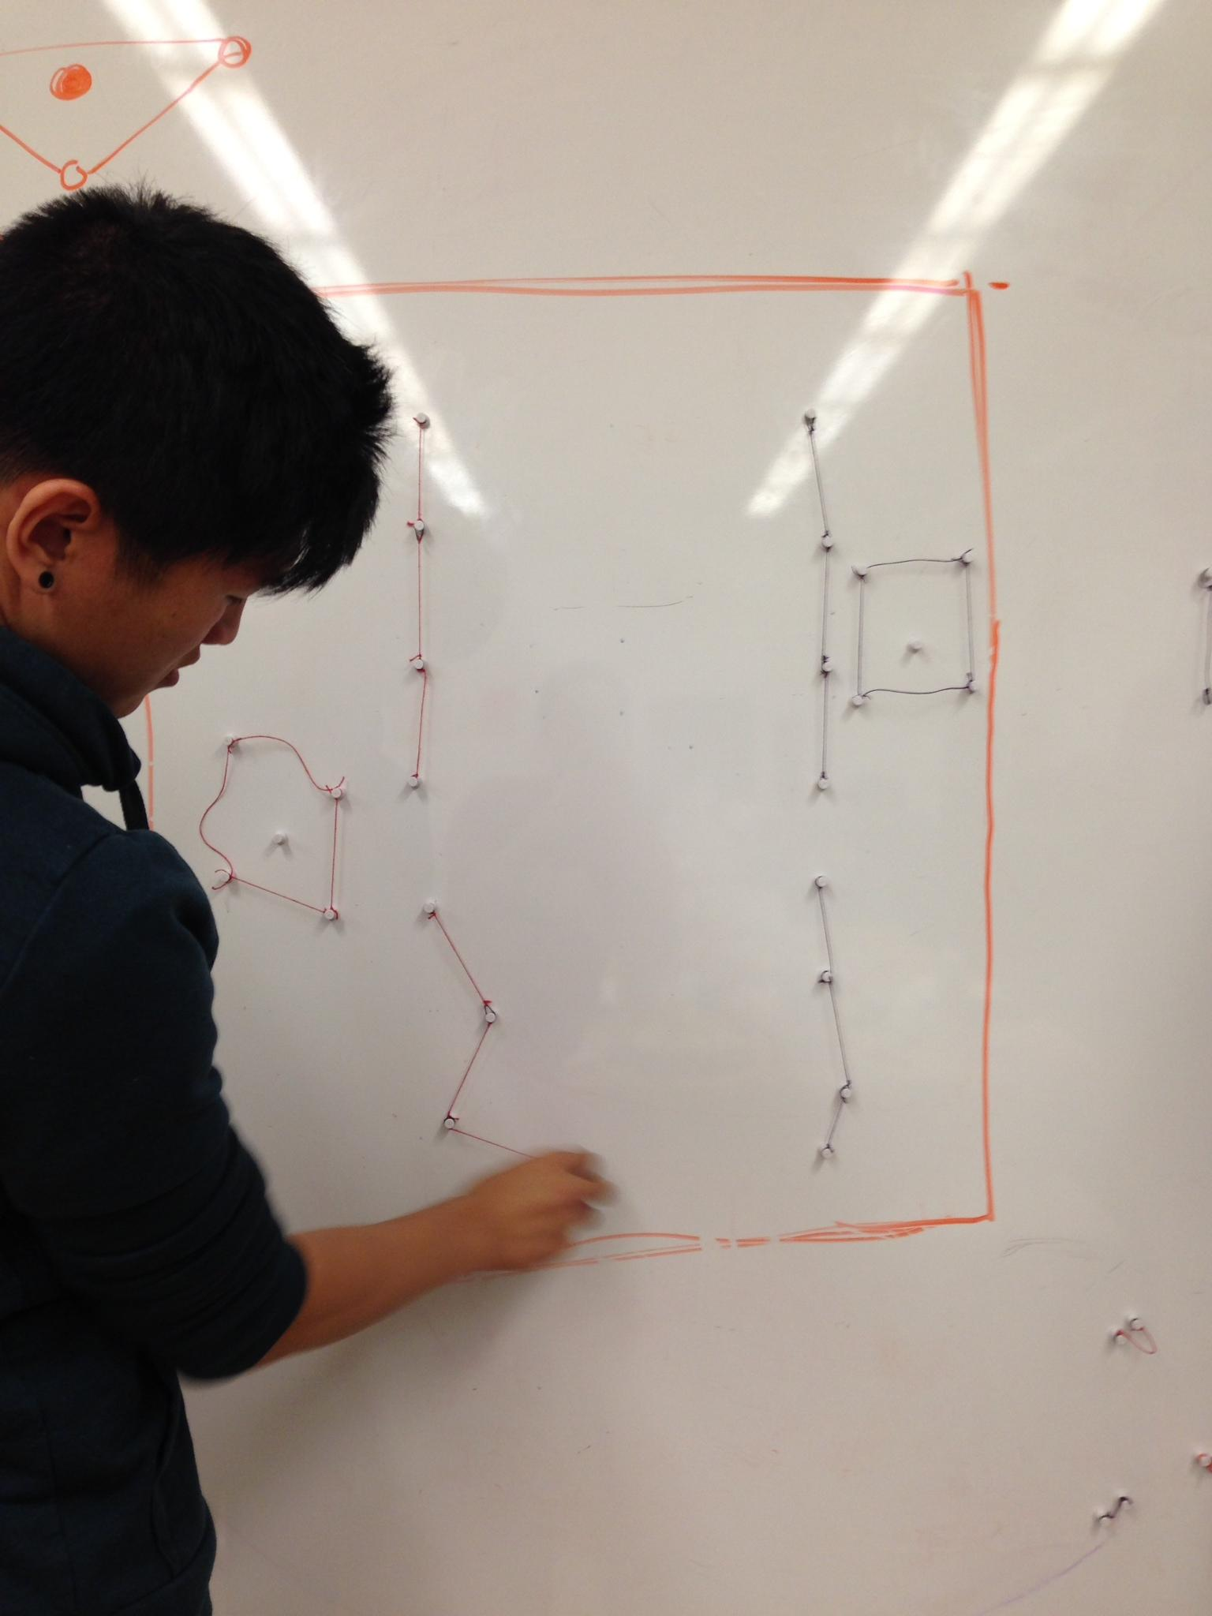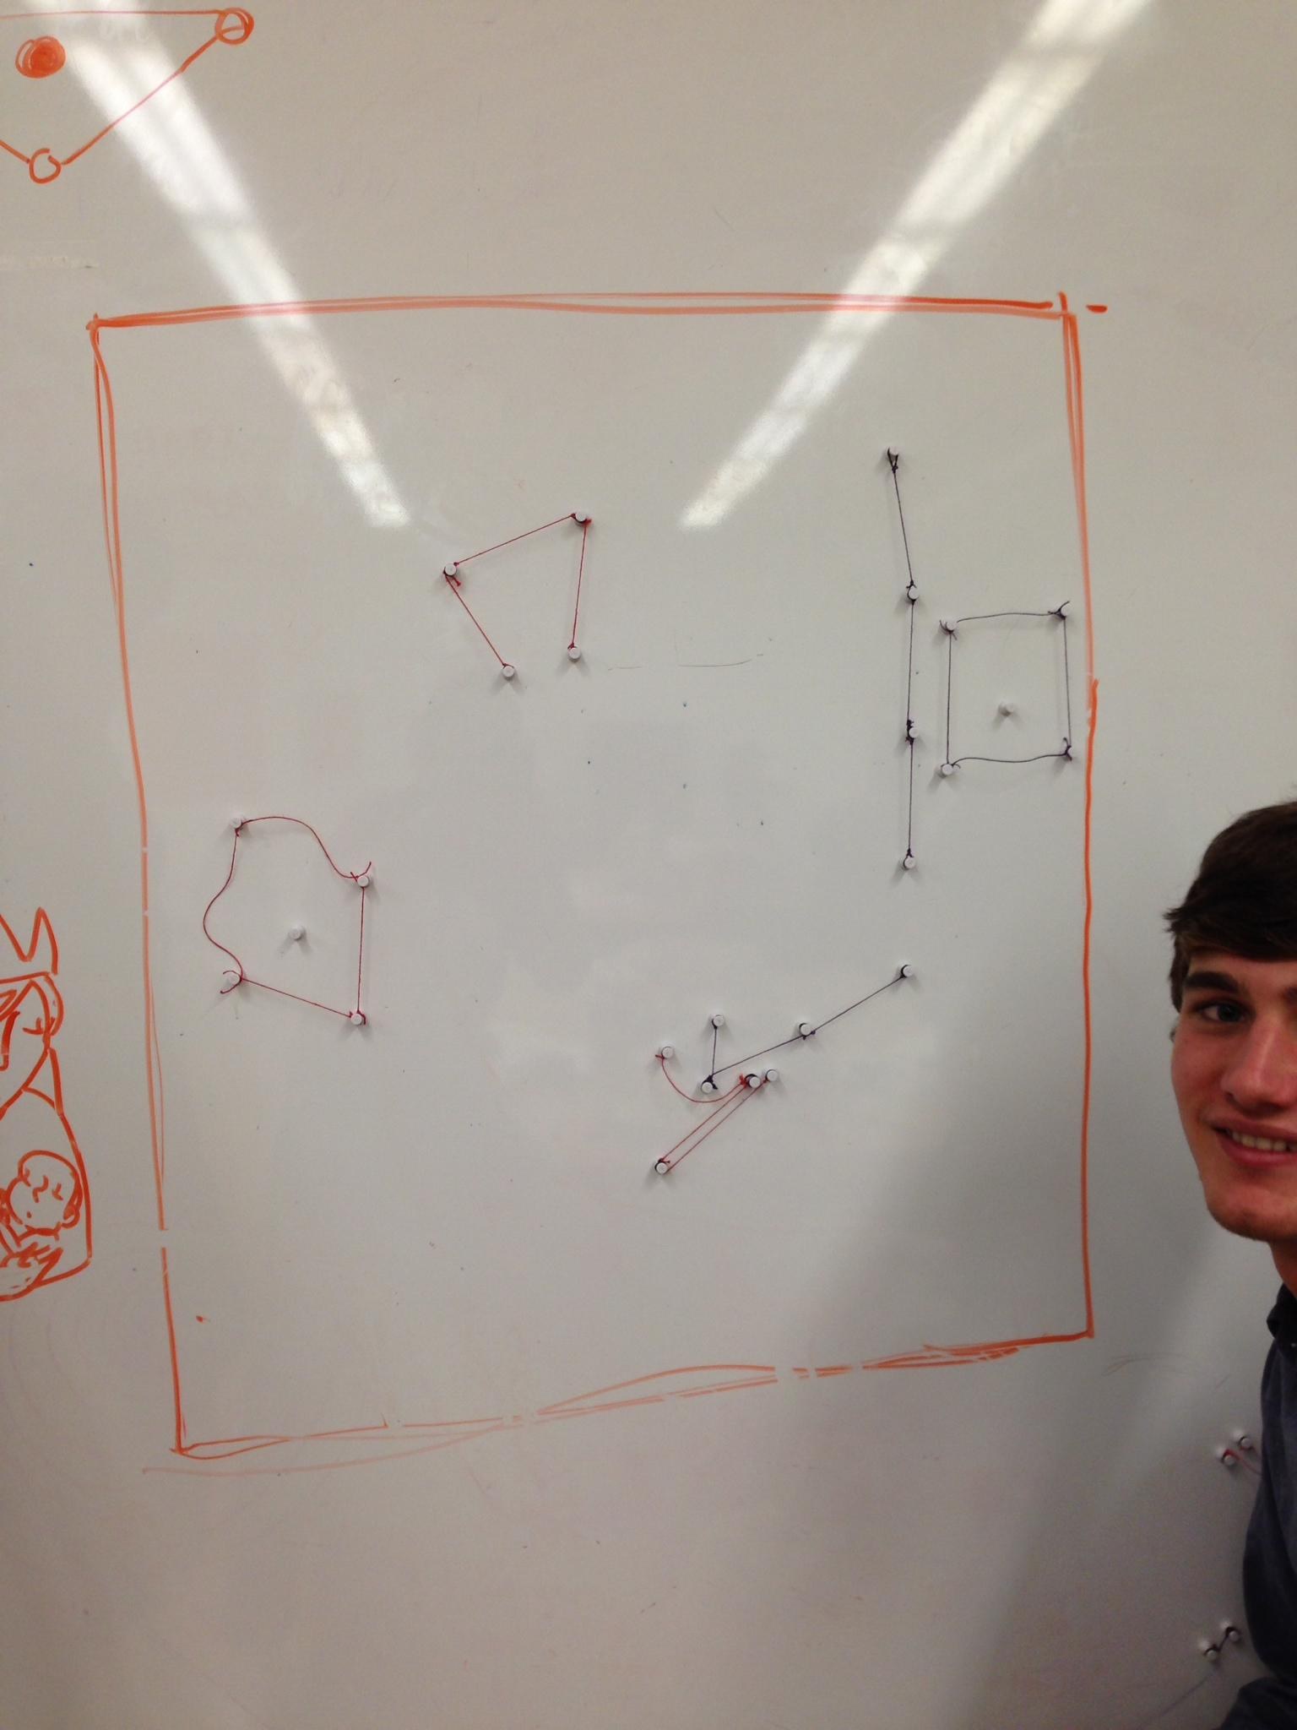

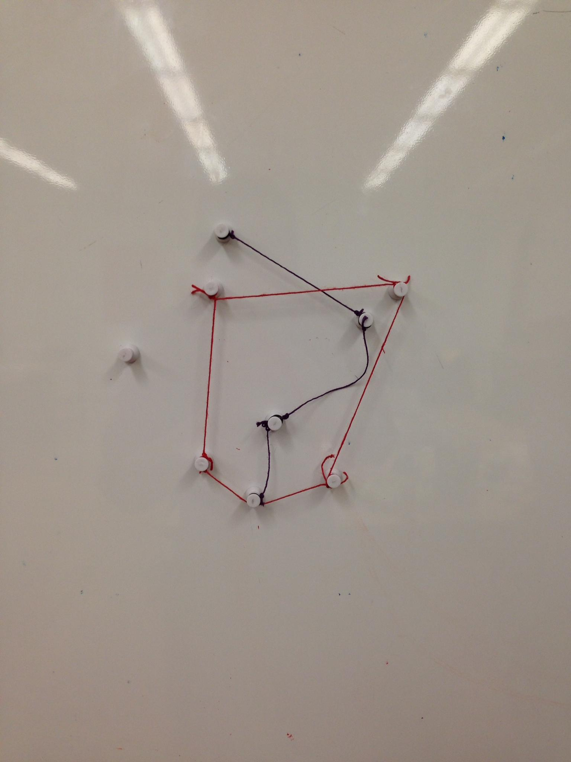The winning move!

Here are our observations from this round:

It was much faster moving across the board since the space is limited and the players could split the ‘soldiers’ into smaller pieces of four, and accordingly was more fun for our playtester. We noted the players talking out some of their thought process and found that they were really thinking about strategy--how many ways there were to destroy the other player’s nodes, whether they should use a structure for offense or defense, etc.

Some of the feedback we got was that the mother seemed really powerful--because of the square structure, it becomes very easy to move the mother very quickly across the board. However, we also noticed players did not move the mothers at all until an enemy approached--we were a little worried about this at first, but then came to consider it similar to the queen in chess: she is stationary for most of the game, but it doesn’t mean she’s “not engaging enough” for the players.

Some of the things we had to think about during this playtest was some of the mechanics: should we allow unlinking of the mom? What happens when a link is reduced to just one piece, is it killed with the rest, or does it stay on the board to be reconnected to another set of pieces?

We decided to enact a few more changes: namely, shorten the links between the mother, since she could move a little too far with the current length strings and dominate other pieces once she is put into play. We also decided to leave single pieces on the board so that they could be reconnected if the player can get within reach.

**Conclusion**

We started out with a lot of varied, crazy ideas on how to approach the topic before settling on magnets and strings. From there, we had to figure out how to balance the game so that it didn’t have too much “dead time” before the players could interact with one another, how to ensure players could move in a way that was fast and rewarding enough, and how to really emphasize the family/multiplayer aspect. We accomplished this by making changes to gameplay boundaries, string lengths and allowing split strings of magnets, and by creating three different roles: mother, baby, and soldiers, all held together by our narrative.